JINDAL VIDYA MANDIR, PRE SCHOOL, RATNAGIRI, 2020-21 ( CIR.NO.B-27)
NOTICE FOR NURSERY, Jr.KG & Sr.KG
RECIPE ACTIVITY – “ COOKING WITHOUT FIRE ”
Dear Parents, Date :- 17 / 10 / 2020
Greetings!!!
“ Cooking with kids is not just about ingredients, recipes and cooking.
Its about harnessing imagination, empowerment and creativity. ”

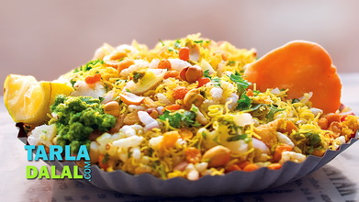
Hello everyone!!! As we all know that our 1st Online Assessment would be over by 23rd Oct.2021. So after that we would like to relax and have some fun. To spend some quality time with our kids, we have arranged a Recipe Activity ie. “ Cooking Without Fire ”. This activity will be held on 31st October, 2021 ie.Saturday. Students have to prepare the given recipe i.e.Bhel by using all the material given below. Activity will be conducted through Zoom Meeting. After preparing the recipe parents have to click photo of their ward with his/her recipe dish and send it to their respective class teacher on their whatsapp group. And enjoy the recipe together.
*Material for making Bhel :- 1) Churmura(Murmura) 2) Farsan (Mix Namkin)
3) Chopped onion 4) Chopped Tomato
5) Shev 6) Salt
7) Lemon 8) Bowl
9) Spoon 10) Plate

* Timings for activity as per class :-
Sr.No. | Class | Day | Date | Time
1 | Nursery | Saturday | 31 – 10 – 2020 | 11:00am to 12:00 noon
2 | Jr.KG |  |  | 3:00pm to 4:00pm
3 | Sr.KG |  |  | 4:30pm to 5:30pm

* Note :- 1) Send photo after Zoom meeting.
2) Parents have to keep the material ready for their child before starting the activity.
3) Zoom meeting ID will be send 5 mins before.
3) For any query call on school phone number 9307605100.

Class teacher Coordinator Principal

